Data Migration - Payroll Management System

Step 1: Go to the “SQl SERVER”, Create new Database.

Go to the SQl SERVER

Create New Database

  - Sql Server: After clicking on to the sql server,Please enter the following values i.e.
a)Server Name.
b) Select the Authentication as “SQL Server Authentication”.
b) User Name
c) Password

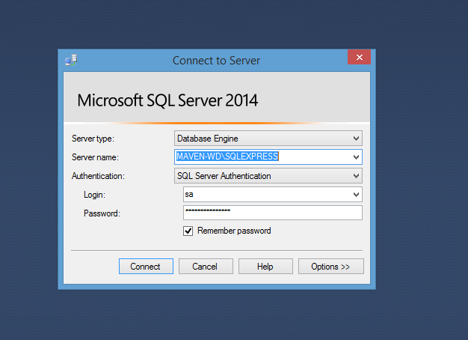
  - Create Database:

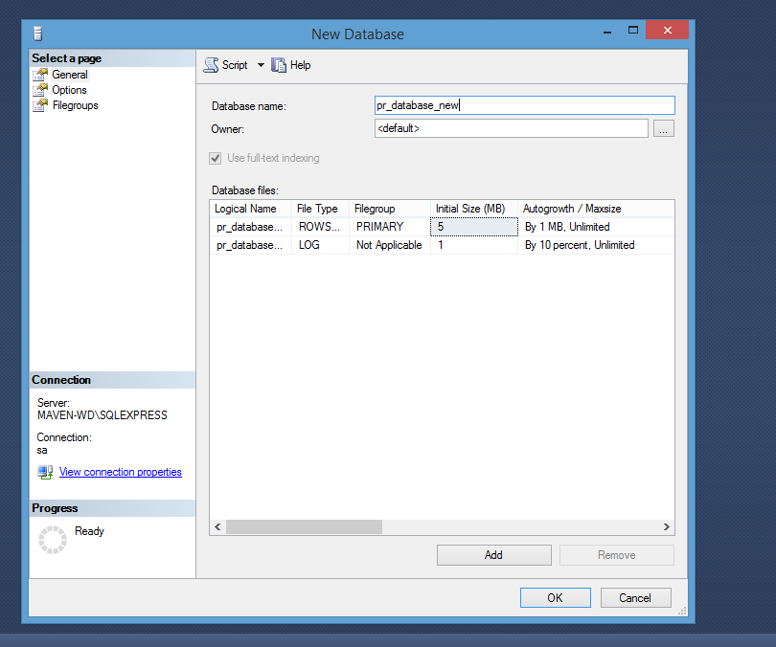
Step 2: Create the tables.

2.1 To create Tables we need Queries And the queries are available in the following path

MainBranch\HRMS\branches\HRMApplication\PAYROLL_SQL_SCRIPTS\payroll_scripts\ 1. payroll_Creations

2.2 Click on “1. payroll_Creations” and open with Notepad++.

2.3 Copy all the Queries from the File.

2.4 Paste the Copied Queries in Sql Server and Excecute it by pressing F5 .

MainBranch

HRMS

branches

HRMApplication

PAYROLL_SQL_SCRIPTS

payroll_scripts

1.payroll_Creations

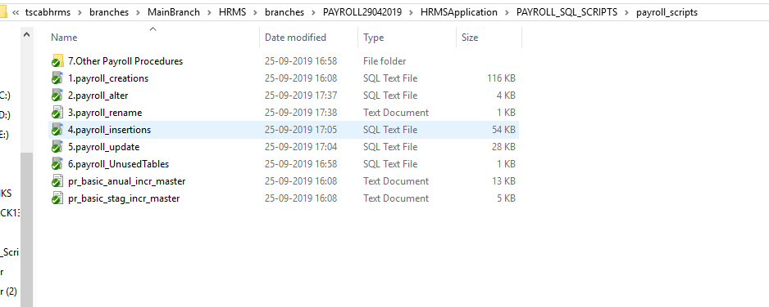

Step 3: Alter the tables.

3.1 To Alter Tables we need Queries And the queries are available in the following path

MainBranch\HRMS\branches\HRMApplication\PAYROLL_SQL_SCRIPTS\payroll_scripts\ 2.payroll_alter

3.2 Click on “2.payroll_alter” and open with Notepad++.

3.3 Copy all the Queries from the File.

3.4 Paste the Copied Queries in Sql Server and Excecute it by pressing F5 .

MainBranch

HRMS

branches

HRMApplication

PAYROLL_SQL_SCRIPTS

payroll_scripts

2.payroll_alter

Step 4: Rename the tables

4.1 To Alter Tables we need Queries And the queries are available in the following path

MainBranch\HRMS\branches\HRMApplication\PAYROLL_SQL_SCRIPTS\payroll_scripts\ 3.payroll_rename

4.2 Click on “3.payroll_rename” and open with Notepad++.

4.3 Copy all the Queries from the File.

4.4 Paste the Copied Queries in Sql Server and Excecute it by pressing F5 .

MainBranch

HRMS

branches

HRMApplication

PAYROLL_SQL_SCRIPTS

payroll_scripts

3.payroll_rename

Step 5: Insert the value into tables.

5.1 To insert the values into the Tables we need Queries And the queries are available in the following path

MainBranch\HRMS\branches\HRMApplication\PAYROLL_SQL_SCRIPTS\payroll_scripts\ 4.payroll_insertions

5.2 Click on “4.payroll_insertions” and open with Notepad++.

5.3 Copy all the Queries from the File.

5.4 Paste the Copied Queries in Sql Server and Excecute it by pressing F5 .

MainBranch

HRMS

branches

HRMApplication

PAYROLL_SQL_SCRIPTS

payroll_scripts

4.payroll_insertions

Step 6: update the tables.

6.1 To update Tables we need Queries And the queries are available in the following path

MainBranch\HRMS\branches\HRMApplication\PAYROLL_SQL_SCRIPTS\payroll_scripts\ 5.payroll_update

6.2 Click on “5.payroll_update” and open with Notepad++.

6.3 Copy all the Queries from the File.

6.4 Paste the Copied Queries in Sql Server and Excecute it by pressing F5 .

MainBranch

HRMS

branches

HRMApplication

PAYROLL_SQL_SCRIPTS

payroll_scripts

5.payroll_update

Step 7: Remove the unused Tabales.

7.1 To update Tables we need Queries And the queries are available in the following path

MainBranch\HRMS\branches\HRMApplication\PAYROLL_SQL_SCRIPTS\payroll_scripts\ 6.payroll_UnusedTables

7.2 Click on “6.payroll_UnusedTables” and open with Notepad++.

7.3 Copy all the Queries from the File.

7.4 Paste the Copied Queries in Sql Server and Excecute it by pressing F5 .

MainBranch

HRMS

branches

HRMApplication

PAYROLL_SQL_SCRIPTS

payroll_scripts

6.payroll_UnusedTables

Step 8: Create Procedures in the Database

8.1 Create Procedures in the Database , we need Procedures to execute And the Procedures are available in the following path

MainBranch\HRMS\branches\HRMApplication\PAYROLL_SQL_SCRIPTS\payroll_scripts\ 7.Other Payroll Procedures

8.2 Click on “7.Other Payroll Procedures” and open with Notepad++.

8.3 Copy all the procedures from the File.

8.4 Paste the Copied Queries in Sql Server and Excecute it by pressing F5 .

8.5 Execute the procedures in the following:

1.get_new_num.sql
2.exist.sql
3.nulls.sql
4.gen_new_transaction.sql
5.month_data.sql

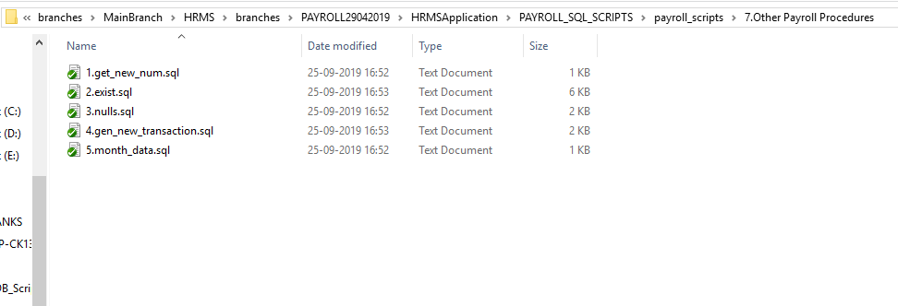

MainBranch

HRMS

branches

HRMApplication

PAYROLL_SQL_SCRIPTS

payroll_scripts

7.Other Payroll Procedures

Step 9: Data Migration For getting the previous Year data From Client.

9.1 Create Procedures in the Database, we need Procedures to execute And the Procedures are available in the following path

MainBranch\HRMS\branches\HRMApplication\PAYROLL_SQL_SCRIPTS\ DataMigration_07aug2019

9.2 Click on “DataMigration_07aug2019” and open the file.

9.3 Now You Can able to see the Number of Procedure.

9.4 Take the procedures based upon numbering and priorities.

9.5 Click on Edit with Notepad++ and Copy it and Excecute it in SQL Server.

9.6 Execute The Following Procedures bases upon the order mentioned below and in the svn as well.

1.dm_emp_mn_task
2.financial period method
3.financial year method
4.sp_dm_emp_master
5.sp_dm_payslip
6.sp_dm_per_ded
7.sp_dm_per_earn
8.sp_dm_rent
9.sp_dm_tax_source
10.other tds deductions
11.sp_insert_exgration_tds_data
12.sp_dm_promotions
13.sp_dm_increments
14.sp_dm_increments_monthend
15.sp_dm_jaiib_caiib
16.sp_dm_pfcontributioncard
17.sp_dm_obshare_main
18.sp_dm_pfnonpayabledata
19.sp_insert_two_sub_Loans
20.sp_insert_two_sub_Loans_priority1
21.sp_insert_two_sub_Loans_priority2
22.sp_insert_fest_loans
23.sp_insert_loans_adjustments
24.sp_insert_fest_loans_child
25.sp_dm_sub_loans
26.sp_dm_main
27.dm_emp_mn_task inserts

MainBranch

HRMS

branches

HRMApplication

PAYROLL_SQL_SCRIPTS

payroll_scripts

DataMigration_07aug2019

